***Binomial random variables***

X is the number of times an event happens in n trials.

Binomial experiment:

Conditions:

1. There are n trials, **fixed** number.
2. Two outcome, “success”(the event happened) and “failure”(didn’t happen).
3. Outcomes in each trial are independent.(or, pop. Is large enough)
4. Probability of “success” is fixed P.

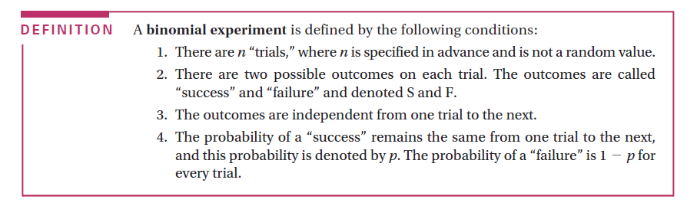

Ex1.

Flip as coin 10 times, X=number of heads. n=10 S=heads, F=tails. Independent, p=0.5 q=1-p=0.5

Roll a die 5times, X=# of 3s and 4s n=5 S=3or4,F=1,2,5,6 p=1/3, q=1-p=2/3

Randomly select 30 DC students, X=#taking biology, n=30, S=biology, F=no biology, not independent(sampling without replacement) -close enough!, p=% of all DC students taking biology

Flip a coing 1 time X=# of heads 1trial=Bernonulli Random variable

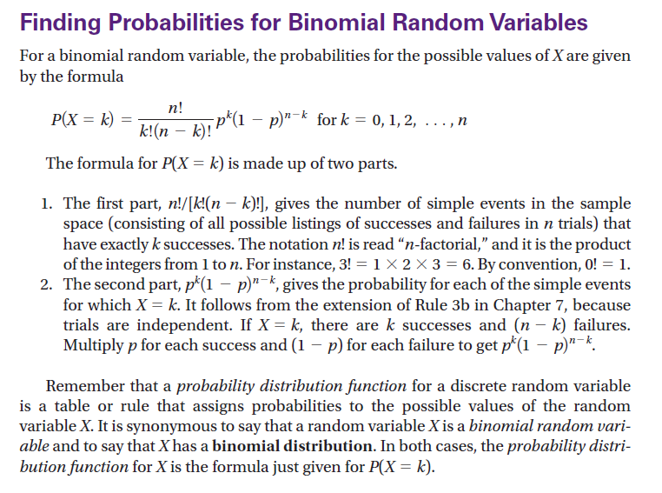

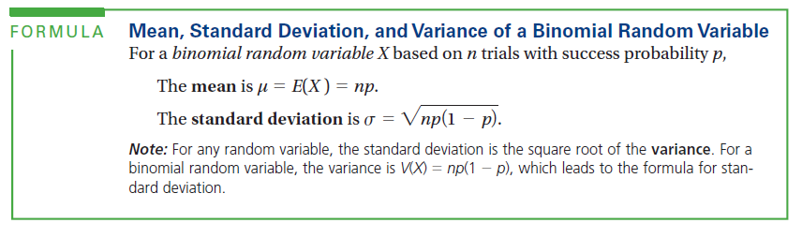

Standard deviation

If 60 O- people show up out of 500 is that weird?

Z=(60-35)/5.7=4.39 within 2 z-scores is usual, more than 2 unusual.

